Maxwell Maia 21236277

Assignment 6

Q1. What is a list?

A1. A list in python stores an ordered collection of items that can be of different types.

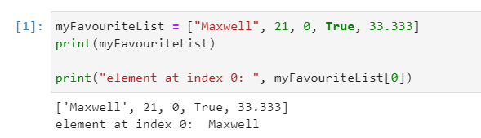

Q2. What is a dictionary?

A2. A Dictionary (called associative array in other languages) is a collection of key-value pairs. The key maps to the value. Like the positions in an array but you specify the key.

Dictionary is {}{}{}{}{}{} with key : value in each. Elements separated by ,

initialize with

days = {}

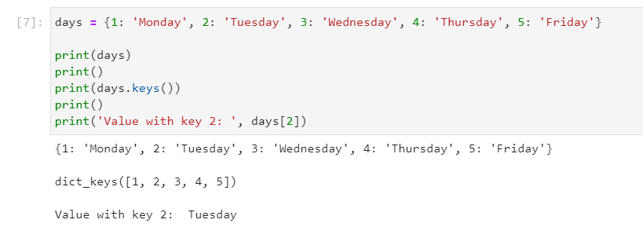

Q3. What is a set?

A3. A set is a collection of values. Can store different types. Set elements are immutable.

Immutable means: the elements cannot be changed.

Set is a list where duplicate values are ignored.

Set is {}{}{}{}{} curly brackets. Elements separated by ,

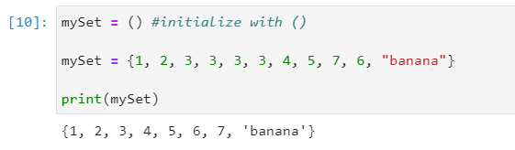

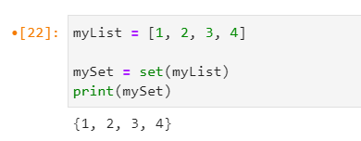A list can be turned into a set.

Q4. What is a tuple?

A4. An ordered collection of objects. Like a list but immutable. The elements of tuples cannot be changed.

Q5. Differentiate between dictionary and set, give example code, output, and paste it. (2 points)

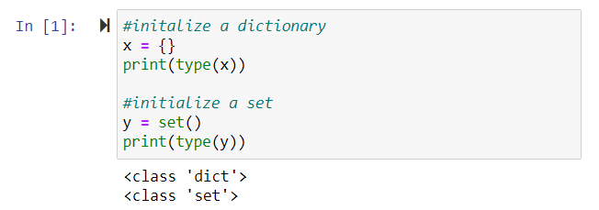

Summary

List - freedom

Tuple - cannot change

Set - cannot change, no duplicates

Dictionary - key-values pairs